Cloned the github repo
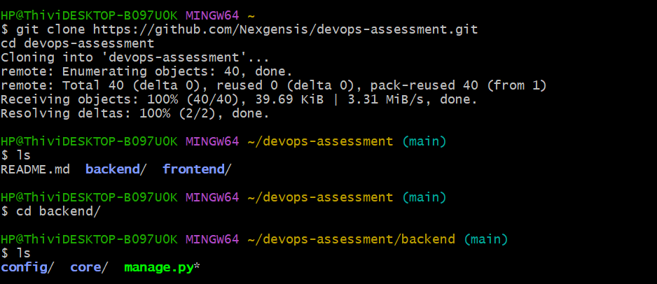
requirements.txt
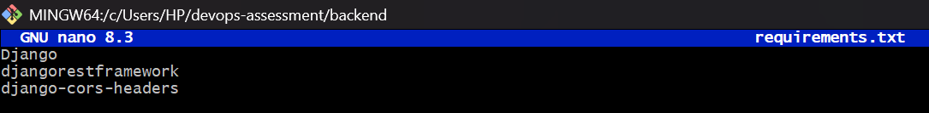
Dockerfile file for backend:Djano
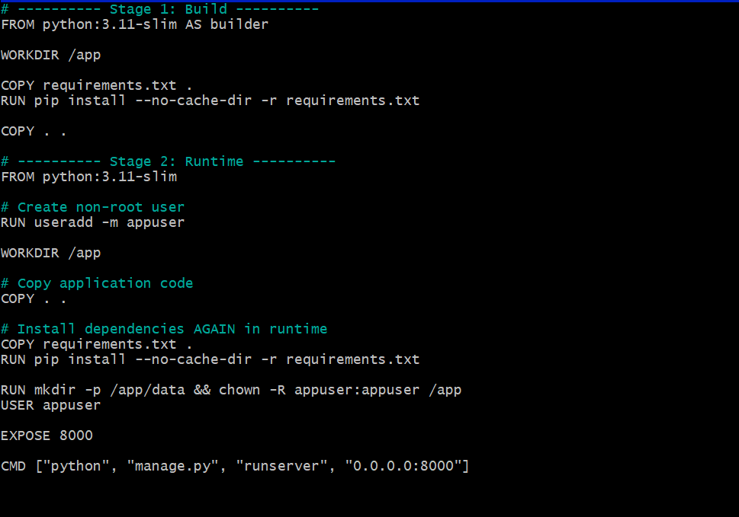
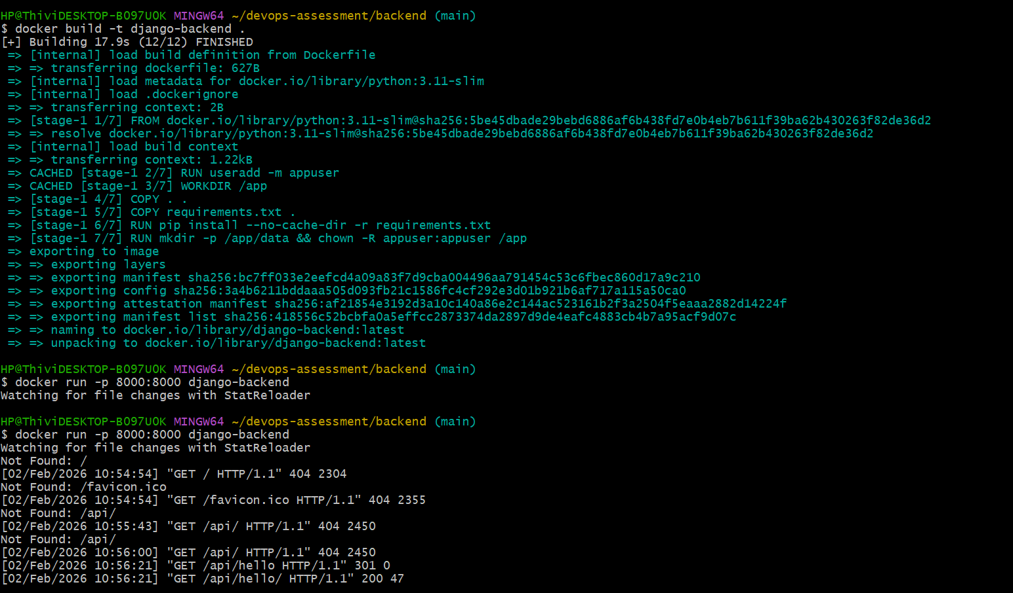
To test with the local
http://localhost:8000/api/hello/

Frontend:React
Dockerfile:
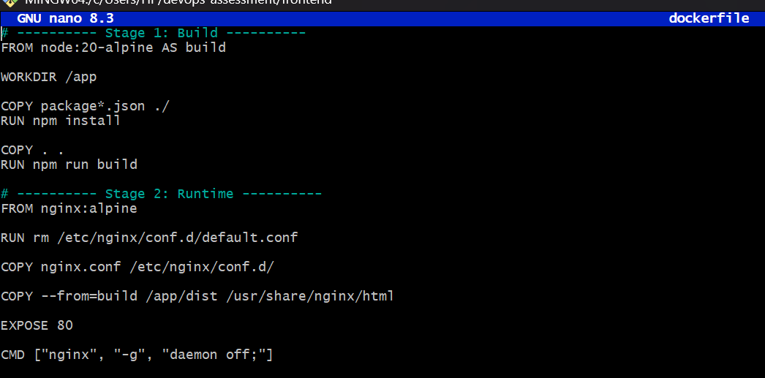

I used a multi-stage Dockerfile for the frontend. The first stage uses Node.js to build the React application, and the second stage uses Nginx to serve the optimized static files

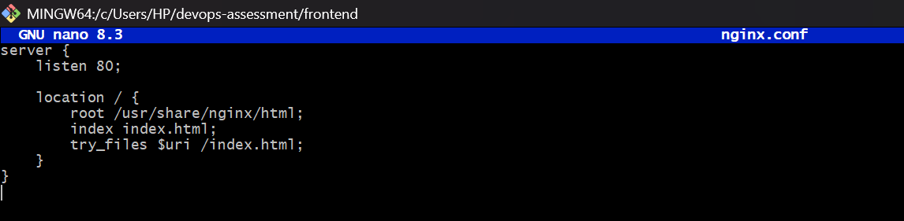
As Default Nginx config is generic and React is a Single Page Application (SPA)
So we use custom nginx.conf to:
- Serve React build files correctly
- Fix page refresh issues
- Make Docker + React work in production
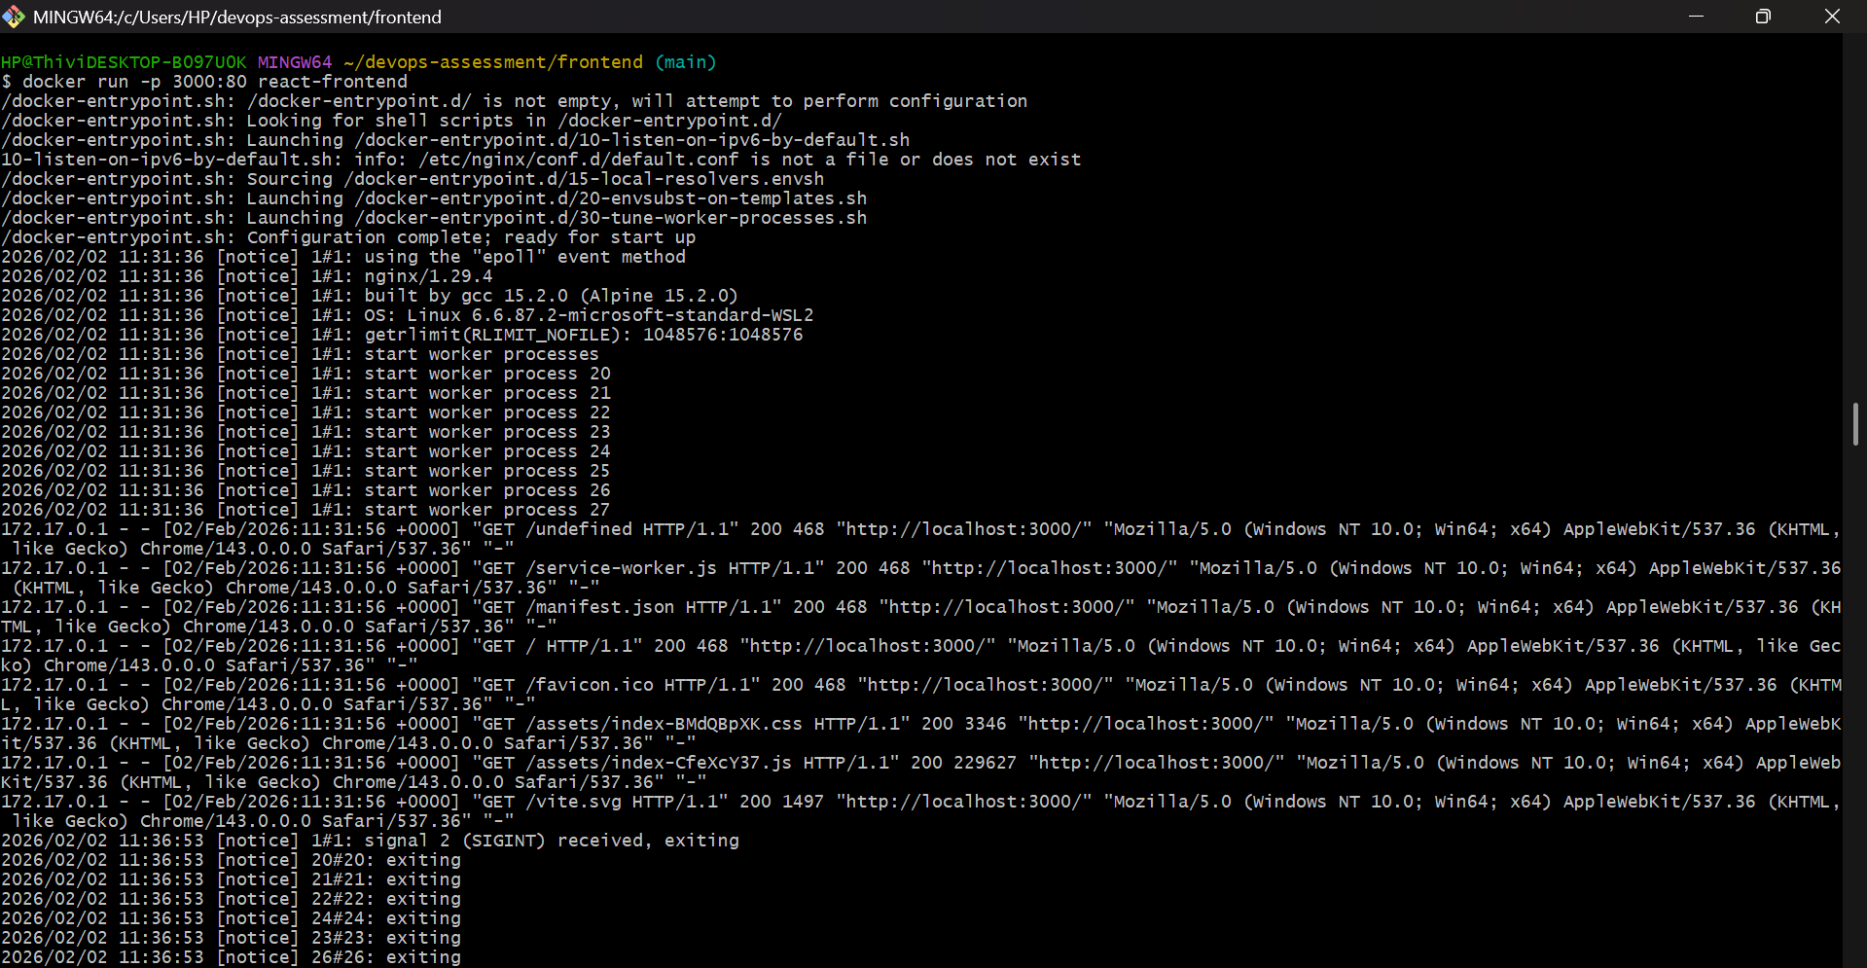

This is due to frontend calling the port 8000 (which is labelled as backend, already in use) that why its failing. To solve this I am using docker-compose file
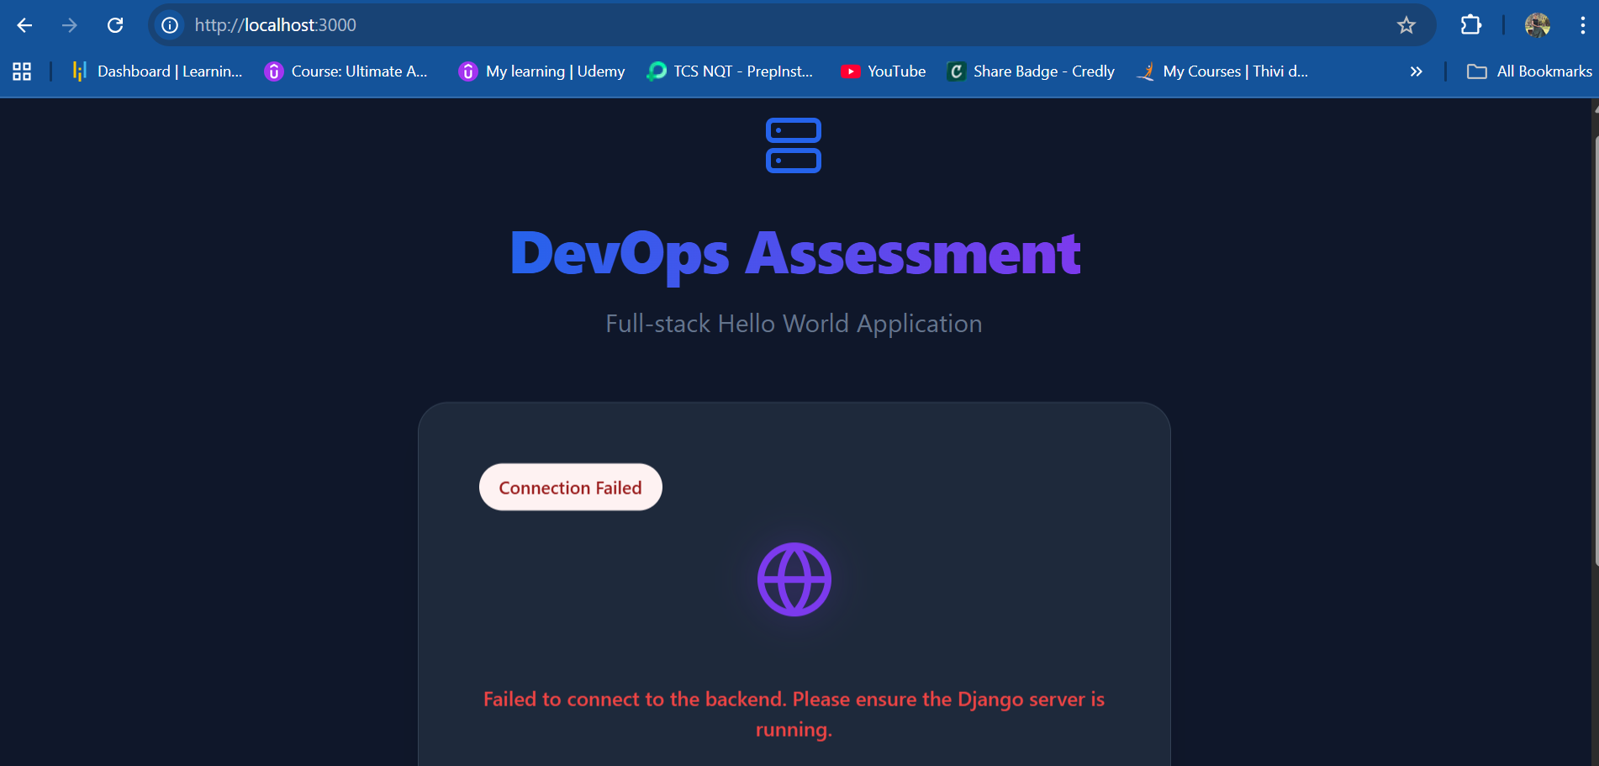

Docker-compose:
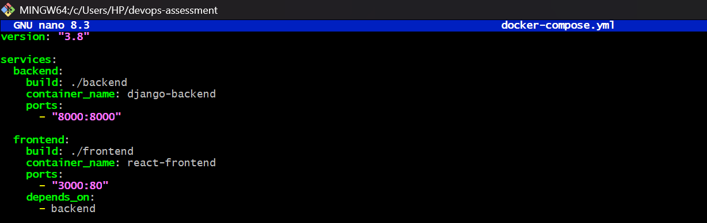

docker compose up --build
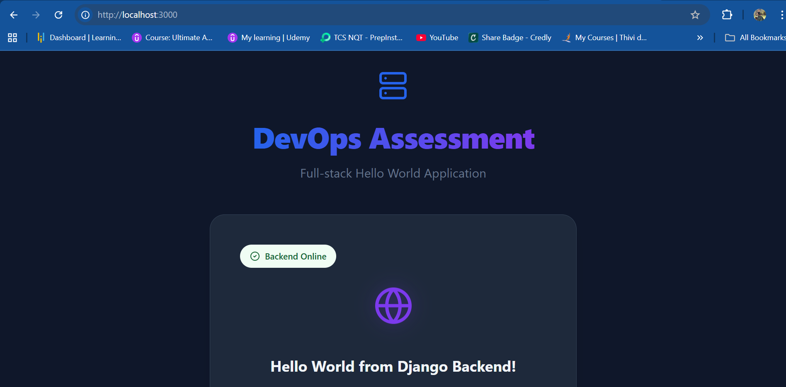
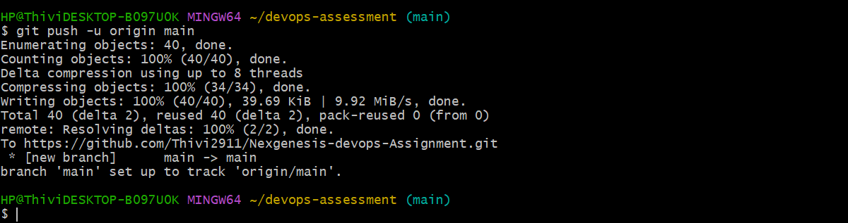
ci-cd.yml file to trigger github actions to deploy the application to docker
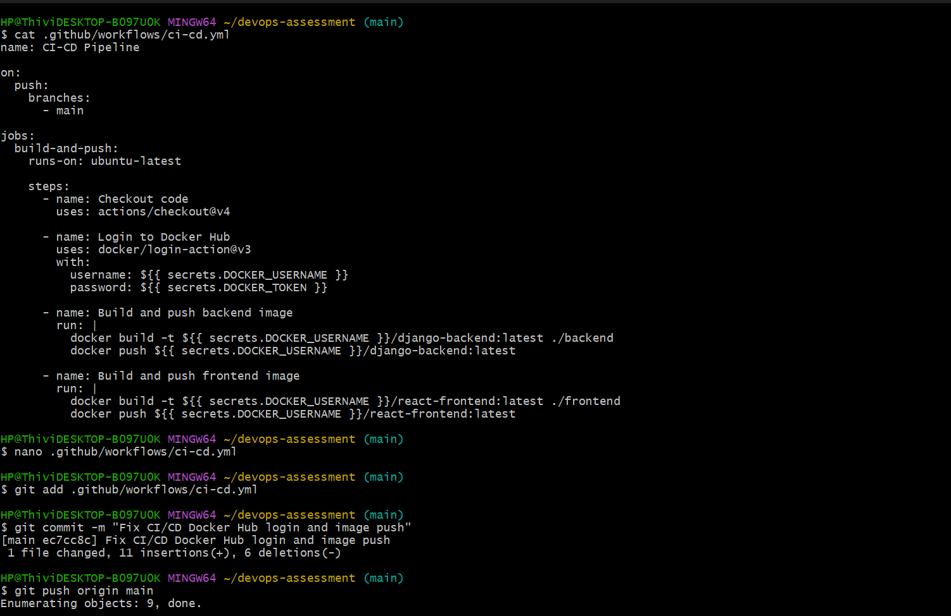
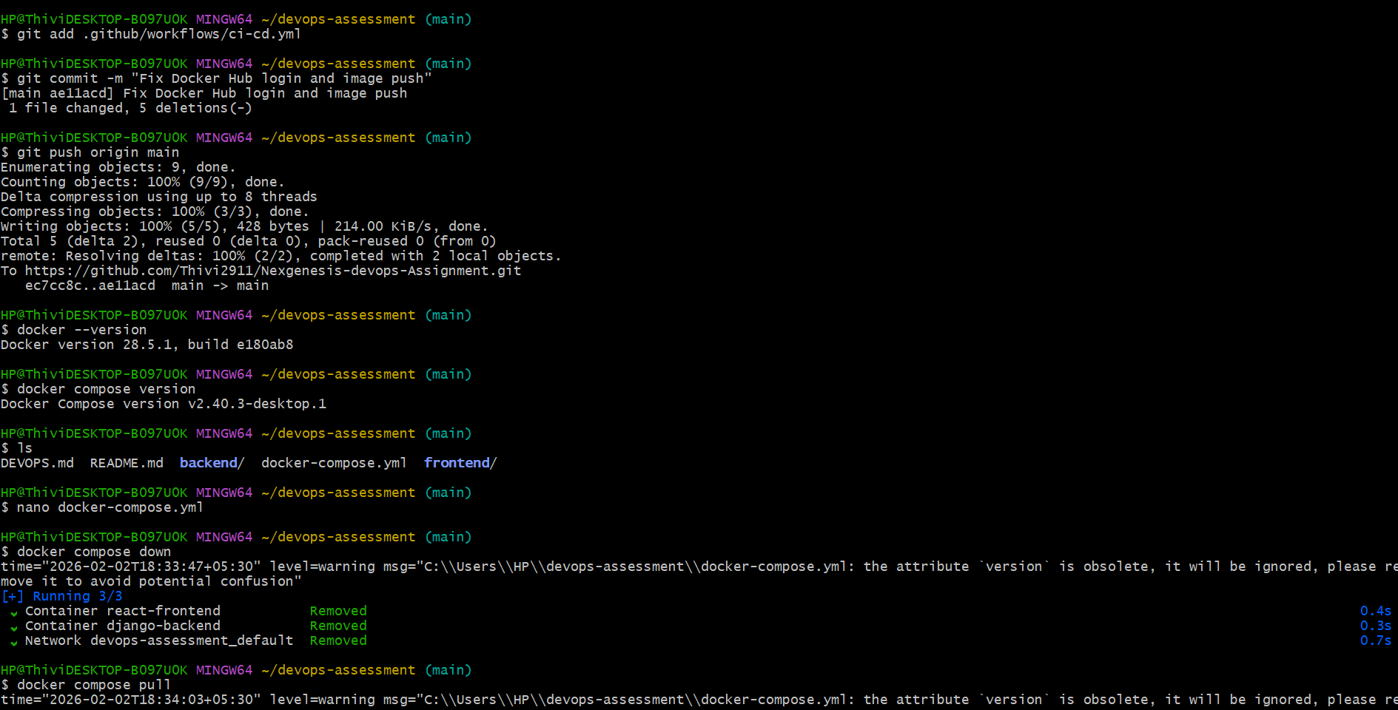
Create secrets and variables to the repository:
